PROJECT REPORT
PERSONAL FINANCE
ADVISOR BOT
FinAdvisor AI
Prepared by: Bhagwat Nagve
Department: Artificial Intelligence & Data Science
1. ABSTRACT
Personal Finance Advisor Bot, shown in the demonstration as FinAdvisor AI, is a web-based application designed to help users organise and understand their personal finances. The video demonstrates a financial dashboard, expense tracking, budget planning, savings goals, and an AI-style financial assistant. These features bring common money-management activities together in one interface.
The dashboard presents financial information in summary cards and charts. The expense section helps users inspect transactions, while the budget module supports comparison between planned spending and actual expenses. Savings goals help users view progress toward a target, and the assistant provides a conversational way to ask general finance questions. The application is intended to make financial information easier to review and support better planning.
This report explains the project’s purpose, problem statement, objectives, features, system workflow, screenshots, basic testing plan, limitations, and possible future improvements. Details that cannot be confirmed from the video are described as suggested implementation ideas, not as verified technical facts.

2. INTRODUCTION
Personal finance management means keeping track of income, spending, savings, and financial goals. Many people record expenses in notebooks or spreadsheets and use separate applications to check balances or plan budgets. When information is spread across different places, it can be difficult to understand total spending or notice a pattern.
FinAdvisor AI aims to provide a central place for these tasks. The interface shown in the video uses a dashboard-oriented layout with navigation between finance modules. It combines visual summaries with more detailed screens, and includes a chat-style assistant. This project is relevant to Artificial Intelligence and Data Science because it brings together structured data, visual analytics, a user interface, and a possible natural-language AI feature.

2.1 Purpose of the Project
The purpose is to make everyday financial tracking simpler and more organised. Users should be able to review their financial position, understand categories of spending, plan budgets, monitor savings goals, and ask general questions through one application.

2.2 Scope
- View financial summaries through a dashboard.
- Review and organise expense transactions.
- Plan spending limits using a budget section.
- Monitor savings goals and progress.
- Ask general financial questions through an AI assistant interface.
- Provide a foundation that can later be extended with secure storage and reporting.

3. PROBLEM STATEMENT AND OBJECTIVES

3.1 Problem Statement
People may find it difficult to maintain accurate records of income and expenses, compare actual spending with a budget, and monitor savings targets consistently. Manual methods take time and can lead to missed entries or calculation errors. Users may also find raw transaction lists difficult to interpret. The project addresses this problem by bringing key finance tasks into a single, easy-to-understand interface.

3.2 Objectives
- Provide a clear overview of personal financial information.
- Make expense records easier to review.
- Help users compare spending against planned budget limits.
- Display savings targets and progress in a visual form.
- Offer a chat interface for general finance-related questions.
- Present useful summaries using cards, charts, tables, and progress indicators.
- Encourage responsible financial planning while reminding users to verify AI-generated suggestions.

3.3 Expected Benefits
The application is expected to reduce the effort needed to review finances, make spending patterns more visible, and help users maintain goals. The benefits depend on correct data entry and on the actual functions implemented in the application.

4. MAIN FEATURES AND MODULES

4.1 Welcome / Account Screen
The video shows a welcome or account-access screen for FinAdvisor AI. This screen introduces the application and provides a starting point for the user. If registration and login are enabled, input validation and secure password handling are important.

4.2 Financial Dashboard
The dashboard is the main overview screen. It shows financial summary cards and visualisations such as expense trends or category breakdowns. Summary cards help the user see important values quickly, while charts help identify changes and major spending categories. The dashboard should use consistent date ranges and currency formatting.

4.3 Expense Tracking
The expense module displays transaction information for review. Useful transaction fields include date, description, category, and amount. Organised categories help the application calculate totals and prepare charts. In a complete implementation, users should be able to add, edit, or remove records only through validated actions.

4.4 Budget Planning
The budget module helps users set or review spending limits for categories. The application can compare the planned amount with actual spending and display progress or remaining amounts. If spending exceeds a limit, the interface should clearly show that the budget has been exceeded instead of presenting a misleading percentage.

4.5 Savings Goals
The savings goals module lets users view targets and progress. A goal may represent an emergency fund, education costs, or a planned purchase. Progress can be calculated by comparing the current saved amount with the target amount. The interface should handle invalid or zero targets safely.

4.6 AI Financial Assistant
The video includes a chat-style assistant interface. This provides a natural way for users to ask general questions about budgets, saving habits, or the meaning of financial summaries. AI responses can be incorrect or incomplete, so they should be treated as general information and checked before making important decisions. The assistant should not invent transactions or expose private data.

4.7 Charts and Visual Summaries
Charts make financial information easier to understand. A monthly trend can show whether expenses are rising or falling, while a category chart can show where money is being spent. Accurate charts depend on correctly recorded transactions and consistent date filters.

5. SYSTEM REQUIREMENTS

5.1 Hardware
- A desktop computer or laptop.
- At least 4 GB RAM for basic use; 8 GB or more is preferable for development.
- A stable internet connection if the AI assistant or storage service is online.

5.2 Software
- Windows, Linux, or macOS operating system.
- A modern web browser such as Chrome, Edge, or Firefox.
- Development tools and source-code editor, if modifying the application.
- A database or storage service if user data must persist between sessions.
- An AI service/API if the assistant uses an external model.

5.3 Technology Note
The video confirms a browser-based interface but does not reliably identify the exact framework, programming language, database, or AI provider. A possible implementation could use HTML, CSS, and JavaScript or a frontend framework, a backend API, a database for transactions and goals, and a protected AI-service connection. These are suggestions only and should be replaced with the actual technologies used in the source code.

6. SYSTEM WORKFLOW
The general workflow begins when the user opens FinAdvisor AI. The application loads available finance data, calculates summary values, and displays the dashboard. The user then chooses a module such as expenses, budget planning, savings goals, or the AI assistant. After a valid update, relevant views should refresh so the user can see the latest information.
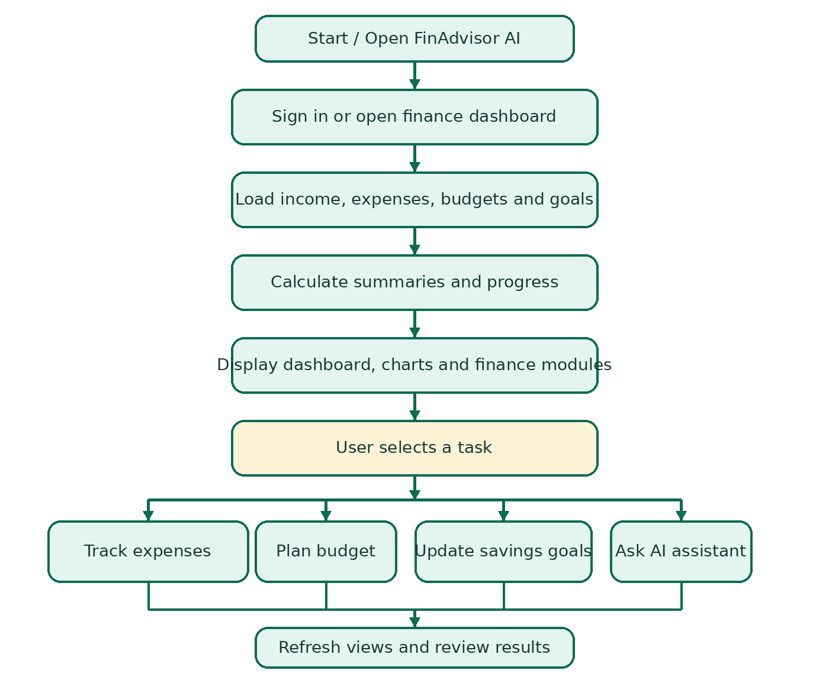
Figure 1. High-level workflow of the FinAdvisor AI project.

6.1 Workflow Steps
- Open the application and sign in if account access is enabled.
- Load the available income, expense, budget, and goal information.
- Calculate totals and prepare summary values.
- Display dashboard cards and charts.
- Open the required module to review or update financial information.
- Ask a general question through the assistant if required.
- Refresh the relevant view and review the updated result.

7. SCREENSHOTS FROM THE DEMONSTRATION
The following images are representative frames extracted from the supplied demonstration video. They show the interface at different points. A screenshot demonstrates the visible screen, but it does not by itself prove that all backend operations have been tested.
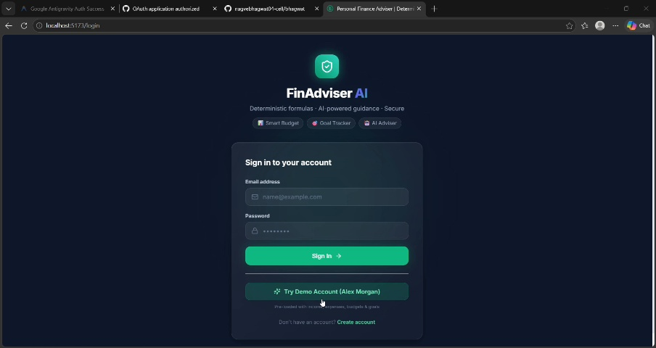
Figure 2. Welcome or account-access screen.
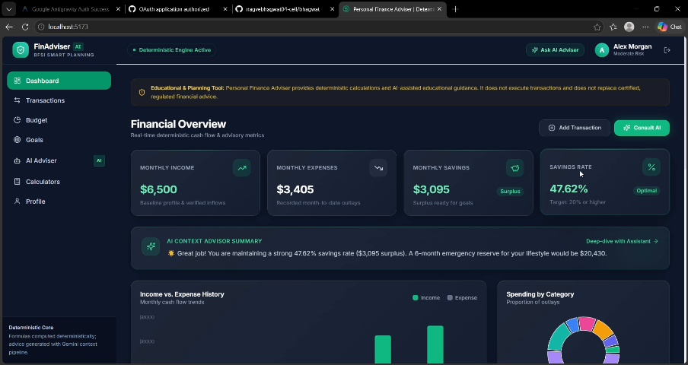
Figure 3. Financial overview dashboard.
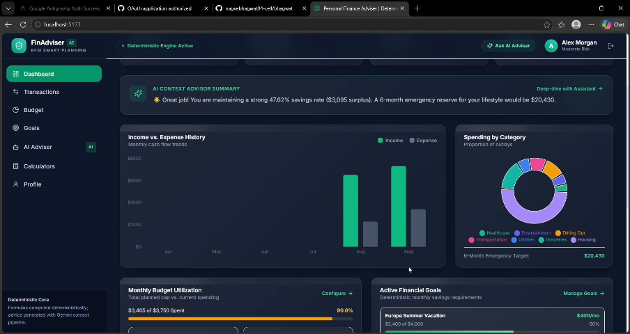
Figure 4. Expense tracking interface.
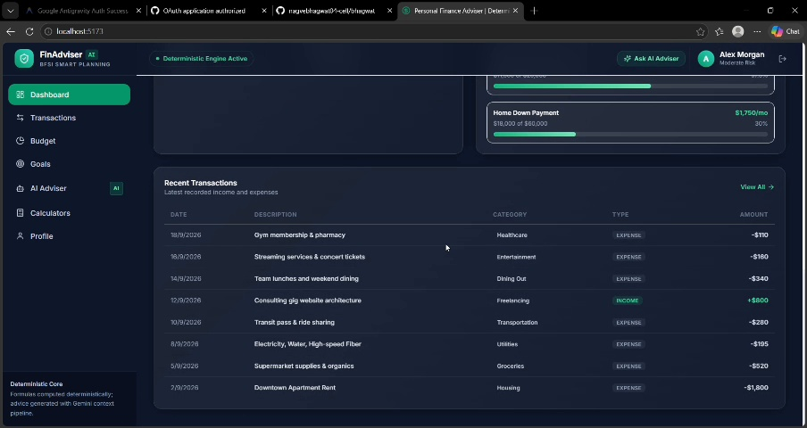
Figure 5. Budget planning interface.
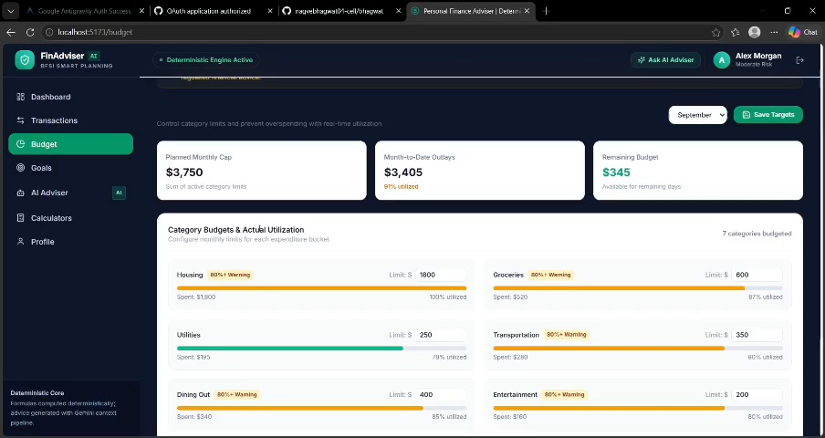
Figure 6. Savings goals interface.
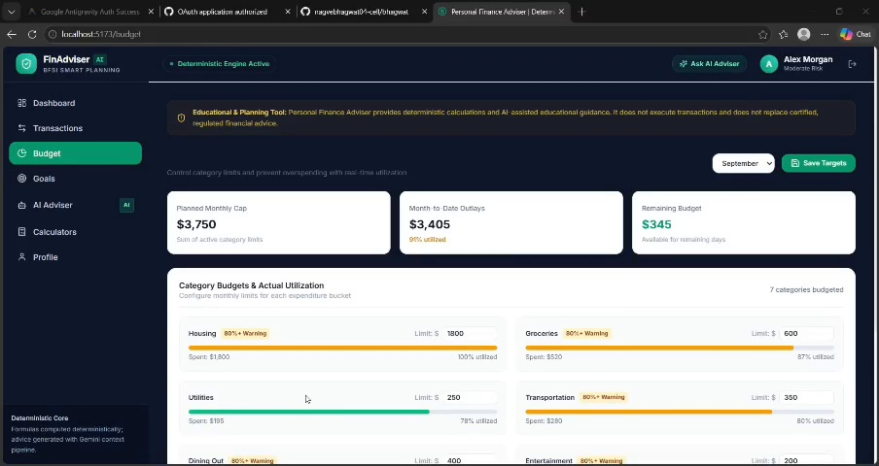
Figure 7. AI financial assistant interface.

7.1 Screenshot Summary
- The welcome screen introduces the application.
- The dashboard gives a quick view of financial summaries.
- The expense page supports transaction review.
- The budget page helps compare actual and planned spending.
- The savings goals page displays targets and progress.
- The AI assistant page provides a chat-based interaction.

8. TESTING AND EXPECTED RESULTS
Testing should be performed on the actual running application. The table below lists suggested tests. The status is intentionally marked “To be tested” because the demonstration video alone cannot confirm that each operation works correctly.
Test | Action | Expected result | Status
1 | Open the application | Main screen loads without layout errors | To be tested
2 | Add an expense | Valid record appears in the transaction list | To be tested
3 | Enter an invalid amount | Validation prevents incorrect data | To be tested
4 | Update a budget | Budget progress reflects spending | To be tested
5 | Update a savings goal | Progress matches saved and target amounts | To be tested
6 | Ask the assistant a question | Relevant response or clear error appears | To be tested
7 | Check account privacy | Unauthorised users cannot view private records | To be tested

8.1 Expected Results
- Financial information is presented in a single dashboard.
- Expenses can be reviewed in an organised form.
- Budget and savings progress are easy to interpret.
- Charts help users identify spending patterns.
- The assistant provides general guidance with appropriate limitations.

9. LIMITATIONS AND FUTURE SCOPE

9.1 Limitations
- The exact software stack and backend operations cannot be confirmed from the video alone.
- Summaries depend on accurate and complete user data.
- AI-generated answers may contain errors and should be checked.
- Automatic bank integration, alerts, exports, or offline support should not be assumed unless implemented.
- Financial data requires strong privacy and security protection.

9.2 Future Improvements
- Add secure login and persistent database storage.
- Allow monthly reports and CSV/PDF export.
- Add recurring expense reminders and budget-limit alerts.
- Provide filters by date, category, and transaction type.
- Add Marathi and other language support to the assistant.
- Explain recommendations using the data and assumptions behind them.
- Add encryption, access controls, and user-controlled data deletion.
- Test usability and AI answer quality with realistic examples.

10. CONCLUSION
Personal Finance Advisor Bot (FinAdvisor AI) is designed to make everyday financial management more organised and accessible. The demonstration brings together a financial dashboard, expense tracking, budget planning, savings goals, and an AI-style financial assistant. By placing these functions in one interface, the project aims to help users review spending, compare expenses with budgets, and monitor savings targets.
The project shows how web-based software, structured financial data, visual analytics, and conversational AI can work together in a practical AI & DS application. Before real-world use, the application should be tested for correct calculations, reliable data handling, privacy, security, and responsible AI behaviour. The assistant should support user understanding rather than replace personal judgement or professional advice.

REFERENCES
- User-provided demonstration video: demo video.mp4.
- MDN Web Docs — web development reference: https://developer.mozilla.org/
- Python documentation, if applicable: https://docs.python.org/3/
- OWASP Cheat Sheet Series — application security guidance: https://cheatsheetseries.owasp.org/

